History of Jordan’s
Do you walk into any shoe store in the mall and see a Michael Jordan symbol on a pair of shoes, or a shirt, or even socks? Did you know that almost every Saturday of the year, the Jordan shoe company releases a pair of shoes? Jordan’s have officially been out for 30 years, this year. There are 29 different types/designs of Jordan’s. Do you know a little bit about Jordan’s and what happened with Air Jordan’s the last 3 decades? Jordan’s have changes a lot over the last 3 decades.
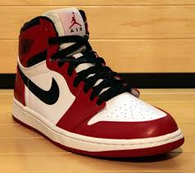 Decade 1
The very first pair of Jordan’s that ever came out was in 1984. They were the Air Jordan 1’s “Notorious”; they were designed to match the Chicago Bulls uniform, the team he was playing for at the time. Did you know before Air Jordan, all basketball shoes were white? The second pair that had come out was in 1987, they were known as the Air Jordan 2’s, “Italian Stalion.” One of the best designed shoes I’ve ever seen. The third were, the Air Jordan 3’s, “Gotta be the shoes.” That names very true, those are one of my favorite shoes.
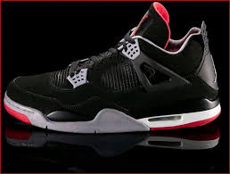
He also has Air Jordan 4’s, “Taking Flight,” which had come out in 1989. I don’t have a pair myself, but I’m waiting until another pair to come out so I can get them. The next year another pair had come out as well you probably heard of them as the Air Jordan 5’s, the pair particularly with the name “The Fighter.” I have a pair of the black, pink, and oranges ones, but my personal favorites are the “Wolf Gray,” “Laneys,” and “Fire Red,” Air Jordan 5’s. in 1991, the “Promised Land,” Air Jordan 6’s had come out. I have two pair the, “Sport Blues” and “Bright Grape” ones.
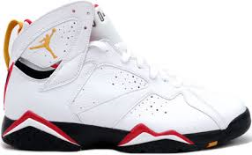
The next ones that had come out were in 1992, the Air Jordan 7’s “Pure Gold.” I want the original “Pure Gold” 7’s. But they haven’t come out again for me to be able to get them yet. This year the Bulls had also won their second straight title Jordan, had also picked up many honors and awards. The next year 1993, the Air Jordan 8’s “Strap In” had come out. I had got a pair of 8’s last year for my birthday; they were yellow, gray, and blue. Then in 1994, the Air Jordan 9’s “Perfect Harmony” had come out. My favorite pair personally of the 9’s is the “Barons,” they’re black, white, and gray.

Decade 2
Jordan had released his 10th pair in 1995, Air Jordan 10’s, “The Legacy Continues.” I have the “Powder Blue” 10’s. Now the best Jordan’s I’ve ever seen or worn, Air Jordan 11’s “Class Act” was the original pair that had come out. This style was designed by Tinker Holtfield. Some people wear this model with business suits instead of dress shoes. When he had come back to basketball, he had worn these and since his teammates had worn all black shoes. He was fined $5’000 for not following the Bulls policy. After he was fined, Nike had made him a pair of shoes in white, black, concord colorway against Colorado. They’re called “Space Jam,” because he wore them in the movie, Space Jam. On that shoe the purple was changed from purple to royal blue for the released version of the shoe.
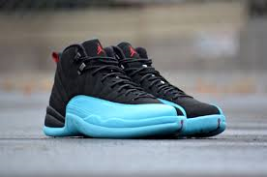
In 1997, Air Jordan 12’s “The Dynasty Continues” was released. They were inspired by Nisshoki (Japanese flag) and a women’s dress boot. Today the 11/12 countdown package (retro) sales for $750 - $800, way above the starting price which is $310. The next year, 1998, Air Jordan 13’s “Black Cat Pounces” were released. On the back of the shoe the hologram imitates the panther’s eye when it’s dark and light is shined at it. Air Jordan 14’s “Race Ready” were released in 1999. On the shoes there are 14 jumpman logos, 7 on each shoe. You can find them, near the toe, near the Achilles heel, above “23” at the heel, at the bottom sole in the middle, on the steel lace tips, one on each end, and on the insoles. This was his first shoe after his retirement.
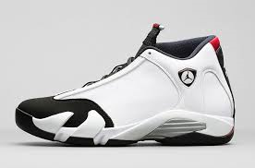
In 2000, the Air Jordan 15 “Speed of Sound” was released. It was the first design that Tinker Holtfield wasn’t behind. It was said to be stiff and the gaiter/ should, could, fall off easily, when playing basketball. Next year 2001, “Marching On,” Air Jordan 15’s was released. They came with keefer which had held the shoes and compact disc containing the Air Jordan XVII song. The Air Jordan 17’s “Jazzed Up,” was released in 2002. The design was inspired by three things, “smooth lines and flow of jazz solo, fine details from an Aston Martin, and the long Air Jordan history of innovations in style.”
In 2003, the “Last Dance,” Air Jordan 18’s was released. They were designed by Tate Kuerbis. Michael Jordan wanted them to look like one piece of leather that drapes over the shoes. The next year 2004, Air Jordan19’s “Full Flex” was released. Also designed by Tate Kuerbis.
Decade 3
Air Jordan 20’s “Living Greatness” was released in 2005. Inspired by bicycling shoes. The same year, the Air Jordan 21’s was released. In 2006, Air Jordan 22, “Performance Luxury DNA,” was released. Air Jordan 23’s “Hit the Afterburners” was released in 2007. Air Jordan 24’s “The Number of Greatness” which was released in 2008. In 2009, “Beyond,” Air Jordan’s was released. Jason Mayden had designed them.
In 2010, 2010 Air Jordan’s war released. “I’ve failed over and over again in my life. And that’s why I succeed.” The quote was attributed to Michael Jordan. Air Jordan 2011 was released in 2011. They were endorsed by Dwayne Wade. It has a unique design along the bottom. These shoes are hand burnished and drafted. In 2012, the Air Jordan 2012 was released. It has two interchangeable sleeves and three insoles adapt to different playing styles. In 2013 Air Jordan XX8 was released. This was the shoe when they decided to bring the numbers back. Air Jordan XX9 should’ve been released September 2014. Another shoe designed by Holtfield supposed to release in both elephant print and knit edition. Also there are 6 rings in which came out I 2008. It’s a combination of 7 Air Jordan shoes that Michael Jordan wore during his 6 champion seasons.

Closing
Air Jordan’s have come out since 1984. This year is their 30th year anniversary. There are 29 different types of Jordan’s, he also has more than that, he and other people have made together, like Spizikes. As you can see Jordan’s have evolved a lot over the past 3 decades. You should’ve known a little bit about Jordan’s if you didn’t before I hope you at least known who Michael Jordan was when you read this. Did you know before you read this Jordan had got fined? Most people wouldn’t have.
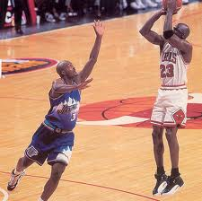
Jordan’s are practically the most popular shoes that have ever come out. I think in the future Jordan’s won’t be as popular because Michael Jordan doesn’t play basketball anymore or even make new shoes, they are retros. I think they’ll be popular for a few more decades but until there is a new design or something to make people like them as much as they do now, but otherwise, a lot of celebrities are getting their own shoes made and there are different designs so people might not like them anymore.

